

Group: Nicholas Agtual, Sofia Escobedo, Andres Mendoza, Christine Tan

ME 241 Materials Laboratory

Tensile Testing

Performed: November 16, 2021

Due: December 7, 2021

Table of Contents

Objective 2

Experimental Equipment 3

Procedure and Observations 4

Data & Results 6

Discussion of Results 8

Conclusion 9

Appendices 11

Appendix B: MATLAB Code 11

References 16

List of Figures

Figure 1 – Instron 3385 H Top Tensile Tester 3

Figure 2 – Instron 3385 H Top Tensile Tester close us 4

Figure 3 – Aluminum before experiment 4

Figure 4: Stress Strain Curve 6

Figure 5: Force Displacement Curve 7

Figure 6: Linear Region of Stress-Strain Curve 7

Figure 7: Steel After Tensile Test 8

Figure 8: Aluminum After Tensile Test 8

Objective

Tensile testing is one of the most common material tests in science and engineering. This is due to many reasons, but the main one being that it is extremely easy to perform and there are a myriad of mechanical properties that can be calculated directly or estimated. Tensile testing is a destructive test; however, only a small sample of material is required. When the tensile test is performed, the elongation of the material is measure using and extensometer and then force applied is measure by the Instron tensile testing machine. With these values, the modulus of elasticity can be calculated using Equation 1, as long as it is in the elastic region.

The objective of the tensile testing laboratory experiment is to find a suitable material for the manufacturing of a component. The company requires a component with a yield strength of 350MPa or higher. The materials of interest that will be tested in this experiment are a 6061-T6 high – strength aluminum alloy and a cold worked 1018 steel alloy.

With the data acquired, a stress-strain curve, as well as the force-displacement curve can be created. These plots will show the behavior of the sample material under different loading conditions. The linear region of the stress-strain curve represents the elastic region. In this region, any elongation that occurs will disappear once the load is removed. Any stresses that cause exceed the elastic region can be considered plastic. Plastic deformation is permanent deformation and does not revert to the original dimensions. Young’s modulus is the slope of the linear region.

|  |  |  |
| --- | --- | --- |
|  |  | Equation 1 |

# Experimental Equipment

Below is a picture illustration of the equipment utilized in this experiment. The tensile tester increases the stress on the tensile plates until eventually the specimen separates into two adjacent atomic planes [2]. This estimates the ideal strength of the tension for each specimen generated by the induced pull force on the tensile tester.

Figure 1 – Instron 3385 H Top Tensile Tester

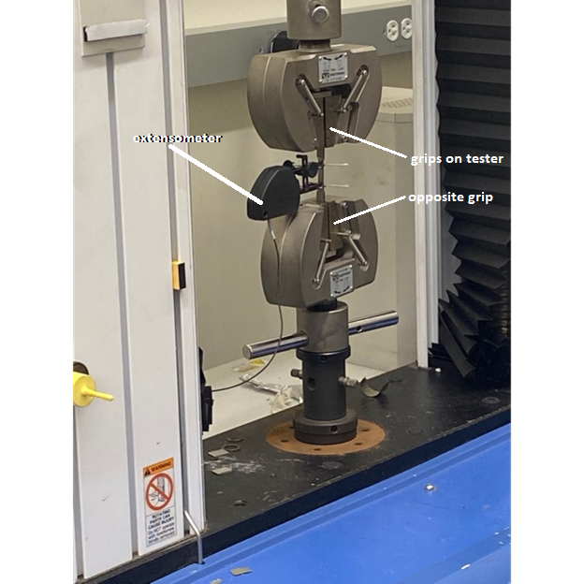

Figure 2 – Instron 3385 H Top Tensile Tester close up

Figure 3 – Aluminum before experiment

# Procedure and Observations

Before beginning the testing part of the experiment, all group members need to be wearing proper protective lab gear, in order to promote the safety of this experiment.

1. Calculate the cross-sectional area for each specimen that will be used during this tensile lab experiment. First, measure both the initial width and thickness to calculate the cross-sectional area.
2. Measure 1 inch away from one end of the specimen and make a mark (towards the middle part of each specimen) to indicate the initial gage length.
3. Make a mark from the opposite end of the specimen, to make another 1-inch mark towards the middle. These lines will be used to line up the grips from the machine on to the center part of the specimen.
4. To facilitate telling each specimen apart, make a mark on the ends of each specimen to later identify the specimen.
5. Ensure that no fingers, hair, or clothes get near proximity to the tensile tester during use and that all proper gear is worn at all times.
6. Take specimen and insert it into the machine tester’s grips. Lining the 1-inch marks of the specimen with the grips on the tester. This is best done with crucible tongs if available.
7. Attach the extensometer to the specimen, making sure that all cables are out of the way from the operational area.
8. The specimen’s rate of failure should be 0.2 in/min. While the machine is working, keep your distance.
9. Take the specimen once the machine has stopped working and make new measurements. Measure the specimen’s final width, thickness, and gage length.
10. To better illustrate the experiments collected data, make a graph for force-displacement as well as for stress-strain curves of the material.
11. Find Young’s modulus using Equation 1, tensile strength, ductility, and toughness. The yield strength should be an offset value of 0.002.

# Data & Results

The data obtained during the experiment can be seen by the four figures below. The graphs detail both stress vs. Strain and force vs displacement. Both data from the graphs were obtained using an extensometer and the information was inputted on the computer. in the stress vs strain graphs the force was calculated in MPa. For the force vs displacement, the graph was calculated in newtons (N).

Figure 4: Stress Strain Curve

Figure 5: Force Displacement Curve

Figure 6: Linear Region of Stress-Strain Curve

The plot for the linear region of the stress-strain curve is invalid. The elongation should not go negative since this is a tensile test, not a compressive test. This is most likely due to experimental error and setup using the extensometer.

Figure 7: Steel After Tensile Test

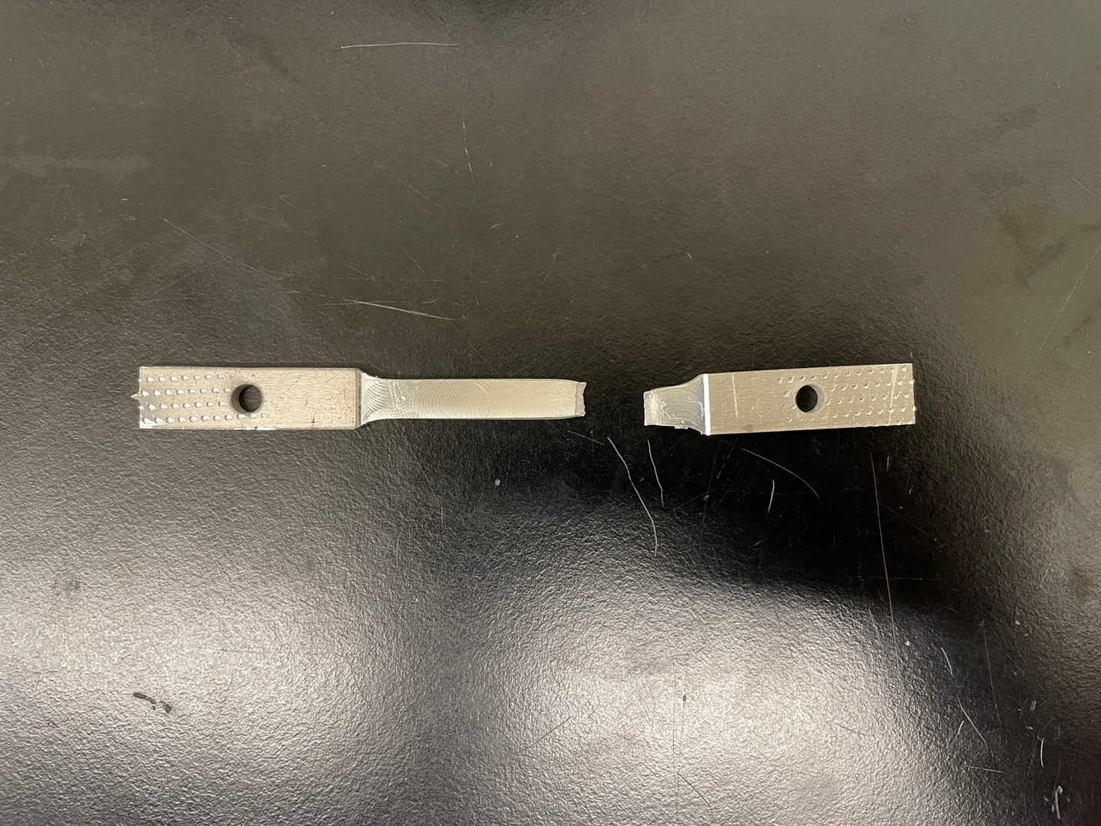

Figure 8: Aluminum After Tensile Test

# Discussion of Results

For this experiment, we were provided with 6061-T6 Aluminum Alloy and Cold Worked 1018 Steel specimens that were tested to see if they had a specific yield strength of 350 MPa.

According to the results obtained, Cold Worked 1018 Steel meets the requirement. According to our data Cold Worked 1018 Steel reached just over 400MPa while aluminum was well below that. Steel also had the least width before failure since it had a higher restraint to the tensile force. Based on the graph and our measurements one can analyze and say that steel is the best fit for the company. The final thickness for aluminum was 2.25 cm while steel had a thickness of 1.17 in the end. From the graph you can see steel's ability to stretch and absorb more force while aluminum was not able to endure the same. Steel typically has a minimum of 370MPa. Our findings seem to line up with that because our data shows our steel had over 400MPa. In addition, aluminum has an average of 280MPa, and our findings show it was well below that number. Steel is almost three times as dense as aluminum meaning it is less likely to bend or deform under stress. Steel is also typically less expensive than aluminum, further backing up why the company should choose steel over aluminum.

Based on our findings and data we can assume that they are accurate based on the average strength of both aluminum and steel. With that being said, there are still a few possible factors that could have caused error in our experiment. One error could be our observation while measuring. Some students used a non-digital measurement while others used the digital one. Another possible error could be the room environment. We conducted the experiment in an uncontrolled room so the temperatures could have changed while taking data for each material. Lastly, the data findings from the computer could have been off while the experiment was taking place. Overall, there was most likely truly little experimental error during our experiment.

# Conclusion

The tensile testing laboratory experiment allowed for a much better understanding for the importance of tensile testing and why it is such a valuable and widely used test in industry. Mechanical properties such as yield strength, ultimate tensile strength, ductility, modulus of elasticity, and poisons ratio can all be calculated directly from the results of the tensile test. Other mechanical properties such as hardness and strain-hardening characteristics can also be determined. One major flaw of the tensile test is the fact that all of the samples need to be manufactured to a certain spec. The dimension of the sample before testing must be determined to compare with the end results, giving the mechanical properties.

The material for the component requires minimum yield strength of 350 MPa. Between the 6061-T6 aluminum alloy and the cold-worked 1018 steel alloy, the steel alloy had a yield strength of about 400 MPa, qualifying the steel as a possible material, while the aluminum alloy had a yield strength of about 310 MPa and fractured with about 340 MPa of stress. The aluminum allow would be incapable of handling 350 MPa of stress, while the steel allow is capable of handling over 350 MPa of stress, while remaining elastic. Since the steel alloy exceeded the required minimum yield strength, the cold worked 1018 steel alloy is recommended as the final component for the component.

# Appendices

## **Appendix B:** **MATLAB Code**

clear; close all;

Experimental Data

% Aluminum

aluminum.LengthInitial = [25.24 25.57];

aluminum.LengthFinal = [28.64 28.94];

aluminum.WidthInitial = [6.35 6.36];

aluminum.WidthFinal = [5.63 5.8];

aluminum.ThicknessIntial = [2.55 2.53];

aluminum.ThicknessFinal = [2.23 2.23];

% Steel

steel.LengthInitial = [25.57 25.82];

steel.LengthFinal = [32.68 31.89];

steel.WidthInitial = [6.48 6.45];

steel.WidthFinal = [4.31 4.53];

steel.ThicknessIntial = [2.5 2.55];

steel.ThicknessFinal = [1.64 1.17];

Force-Displacement Curve

% ----- Aluminum -----

% -- Sample 1 --

% Reading excel file and assigning variable for force data - aluminum sample 1

aluminum1Force = xlsread('Tensile Test Results.xlsx', 'ExperimentalData', 'C12:C684');

% Reading excel file and assigning variable for displacement data - aluminum sample 1

aluminum1Displacement = xlsread('Tensile Test Results.xlsx', 'ExperimentalData', ...

'F12:F684');

% Creating new figure

figure(1);

% Allowing for mulptiple lines

hold on;

% Turning grid on

grid on;

% Setting y-axis limit

ylim([0 9500]);

% Plotting force-displacement curve for aluminum - sample 1

plot(aluminum1Displacement, aluminum1Force, 'DisplayName', 'Aluminum - Sample 1');

% -- Sample 2 --

% Reading excel file and assigning variable for force data - aluminum sample 2

aluminum2Force = xlsread('Tensile Test Results.xlsx', 'ExperimentalData', 'M12:M601');

% Reading excel file and assigning variable for displacement data - aluminum sample 2

aluminum2Displacement = xlsread('Tensile Test Results.xlsx', 'ExperimentalData', ...

'P12:P684');

% Plotting force-displacement curve for aluminum - sample 2

plot(aluminum2Displacement, aluminum2Force, 'DisplayName', 'Aluminum - Sample 2');

% ----- Steel -----

% -- Sample 1 --

% Reading excel file and assigning variable for force data - steel sample 1

steel1Force = xlsread('Tensile Test Results.xlsx', 'ExperimentalData', 'W12:W1217');

% Reading excel file and assigning variable for force data - steel sample 1

steel1Displacement = xlsread('Tensile Test Results.xlsx', 'ExperimentalData', ...

'Z12:Z1217');

% Removing negative displacement values

steel1DisplacementL = steel1Displacement(1:270);

% Removing same element in force vector

steel1ForceL = steel1Force(1:270);

% Plotting force-displacement curve for steel - sample 1

plot(steel1Displacement, steel1Force, 'DisplayName', 'Steel - Sample 1');

% -- Sample 2 --

% Reading excel file and assigning variable for force data - steel sample 2

steel2Force = xlsread('Tensile Test Results.xlsx', 'ExperimentalData', 'AG12:AG1253');

% Reading excel file and assigning variable for force data - steel sample 2

steel2Displacement = xlsread('Tensile Test Results.xlsx', 'ExperimentalData', ...

'AJ12:AJ1253');

% Removing negative displacement values

steel2DisplacementL = steel2Displacement(1:270);

% Removing same element in force vector

steel2ForceL = steel2Force(1:270);

% Plotting force-displacement curve for steel - sample 2

plot(steel2Displacement, steel2Force, 'DisplayName', 'Steel - Sample 2');

% Axis Descriptors

xlabel('\emph {Displacement (mm)}', ...

'fontsize', 14, 'Interpreter', 'latex');

ylabel('\emph {Force (N)}', 'fontsize', 14, 'Interpreter', 'latex');

title('\emph {Force vs. Displacement}', 'fontsize', 16, ...

'Interpreter', 'latex');

legend('location', 'northwest', 'NumColumns', 2);

Calculations

% -- Aluminum --

% Area

aluminum.InitialArea = aluminum.WidthInitial .* aluminum.ThicknessIntial;

% Stress

aluminum.Stress1 = (aluminum1Force ./ aluminum.InitialArea(1))';

aluminum.Stress2 = (aluminum2Force ./ aluminum.InitialArea(2))';

% Strain

aluminum.Strain1 = (aluminum1Displacement ./ aluminum.LengthInitial(1))';

aluminum.Strain2 = (aluminum2Displacement ./ aluminum.LengthInitial(2))';

% -- Steel --

% Area

steel.InitialArea = steel.WidthInitial .* steel.ThicknessIntial;

% Stress

steel.Stress1 = (steel1Force ./ steel.InitialArea(1))';

steel.Stress2 = (steel2Force ./ steel.InitialArea(2))';

% Strain

steel.Strain1 = (steel1Displacement ./ steel.LengthInitial(1))';

steel.Strain2 = (steel2Displacement ./ steel.LengthInitial(2))';

Stress-Strain Curve

% ----- Aluminum -----

% Creating new figure

figure(2);

% Allowing for multiple plots

hold on;

% Turning grid on

grid on;

% Setting y-axis limit

% Plotting stress-strain curve for aluminum - sample 1

plot(aluminum.Strain1, aluminum.Stress1, 'DisplayName', 'Aluminum - Sample 1');

% Plotting stress-strain curve for aluminum - sample 2

plot(aluminum.Strain2, aluminum.Stress2, 'DisplayName', 'Aluminum - Sample 2');

% ----- Steel -----

% Plotting stress-strain curve for steel - sample 1

plot(steel.Strain1, steel.Stress1, 'DisplayName', 'Steel - Sample 1');

% Plotting stress-strain curve for steel - sample 2

plot(steel.Strain2, steel.Stress2, 'DisplayName', 'Steel - Sample 2');

% Axis Descriptors

xlabel('\emph {Strain ($${\frac{mm}{mm})}$$}', ...

'fontsize', 14, 'Interpreter', 'latex');

ylabel('\emph {Stress (MPa)}', 'fontsize', 14, 'Interpreter', 'latex');

title('\emph {Stress vs. Strain}', 'fontsize', 16, ...

'Interpreter', 'latex');

legend('location', 'northwest', 'NumColumns', 2);

% Plot for linear Region

% Creating new figure

figure(3);

% Allowing for multiple plots

hold on;

% Turning grid on

grid on;

% Setting y-axis limit

% Plotting stress-strain curve for aluminum - sample 1

plot(aluminum.Strain1(1:220), aluminum.Stress1(1:220), 'DisplayName', 'Aluminum - Sample 1');

% Plotting stress-strain curve for aluminum - sample 2

plot(aluminum.Strain2(1:175), aluminum.Stress2(1:175), 'DisplayName', 'Aluminum - Sample 2');

% ----- Steel -----

% Plotting stress-strain curve for steel - sample 1

plot(steel.Strain1(1:250), steel.Stress1(1:250), 'DisplayName', 'Steel - Sample 1');

% Plotting stress-strain curve for steel - sample 2

plot(steel.Strain2(1:250), steel.Stress2(1:250), 'DisplayName', 'Steel - Sample 2');

% Axis Descriptors

xlabel('\emph {Strain ($${\frac{mm}{mm})}$$}', ...

'fontsize', 14, 'Interpreter', 'latex');

ylabel('\emph {Stress (MPa)}', 'fontsize', 14, 'Interpreter', 'latex');

title('\emph {Stress vs. Strain in Elastic Regime}', 'fontsize', 16, ...

'Interpreter', 'latex');

legend('location', 'northwest', 'NumColumns', 2);

# References

1. Francois, D., & Pineau, A. (2002). *From Charpy to Present Impact Testing (Volume 30) (European Structural Integrity Society, Volume 30)* (1st ed.) [E-book]. Elsevier Science.
2. IAIN., D. C. (2018). *Finnie's notes on Fracture Mechanics: Fundamental and practical lessons*. SPRINGER.
3. Lab Manual (Camacho, 2021).
4. J. R. Taylor, “Principal Formulas in Part 1” in An Introduction to Error Analysis: The Study of Uncertainties in Physical Measurements, (University Science Books, 1996), Vol. 9, Chapter 3.